**Rational Unified Process (RUP)**

**Why RUP?**

* It brings together elements from all of the generic process models.
  + 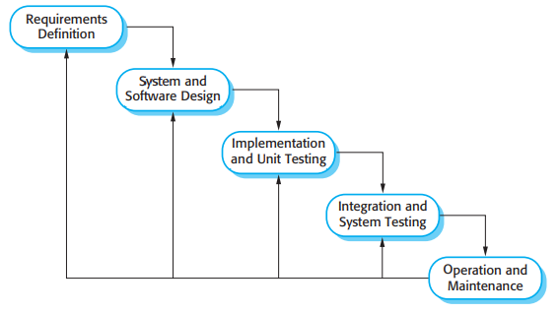
* It illustrates good practice in specification and design.
* It supports prototyping and incremental delivery.
* Phases in the RUP are more closely related to business rather than technical concerns which suits Job-Z because we want to scale it to be a business in the near future!

**Benefits of RUP**

* The RUP recognizes that conventional process models present a single view of the process. In contrast, the RUP is normally described from three perspectives:
  + A dynamic perspective, which shows the phases of the model over time.
  + A static perspective, which shows the process activities that are enacted.
  + A practice perspective, which suggests good practices to be used during the process.
* Phases in the RUP are more closely related to business rather than technical concerns which suits Job-Z because we want to scale it to be a business in the near future!
* Document customer requirements and keep track of these requirements
* Use graphical UML models to present static and dynamic views of the software

**Phases of RUP**

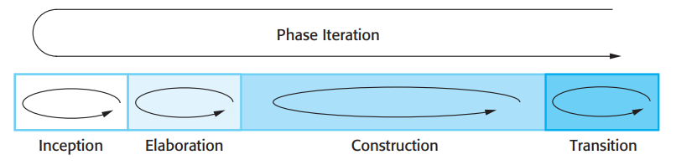

1. **Inception:** The goal of the inception phase is to establish a business case for the system. You should identify all external entities (people and systems) that will interact with the system and define these interactions.
2. **Elaboration:** The goals of the elaboration phase are to develop an understanding of the problem domain, establish an architectural framework for the system, develop the project plan, and identify key project risks.
   1. On completion of this phase you should have a requirements model for the system, which may be a set of **UML use-cases**, an **architectural description**, and a **development plan** for the software.
3. **Construction:** The construction phase involves system design, programming, and testing. Parts of the system are developed in parallel and integrated during this phase.
   1. On completion of this phase, you should have a working software system and associated documentation that is ready for delivery to users.
4. **Transition:** The final phase of the RUP is concerned with moving the system from the development community to the user community and making it work in a real environment.
   1. On completion of this phase, you should have a documented software system that is working correctly in its operational environment.

**How Will We Make The Phases Work?**

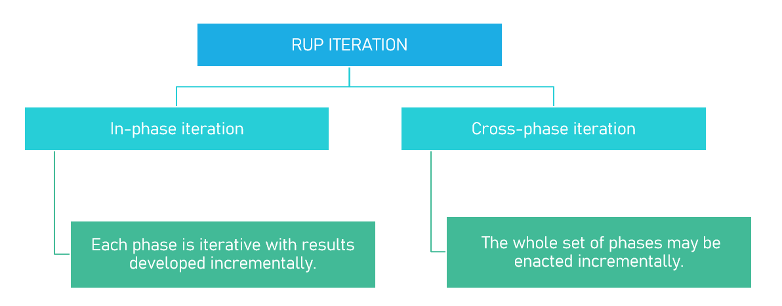

We will be using both simultaneously iterations:

* In-phase Iteration
  + UML Use-Case diagrams will be iteratively reviewed and changed with each advancement in the construction phase(s)
  + The Construction phase will be repeated multiple times separately because the Job-Z application will not be developed in one seating and each version will be documented.
* Cross-phase Iteration
  + The Transition phase will be repeated after every iteration of the rest of the phases. In other words, a version of the application will be deployed for user testing purposes.

